Punto fijo

Ejemplo

clear all

syms c;

f=exp(-c);

xr(1)=double(subs(f,c,0));

iter(1) = 1;

imax = 10;

es=0.5;

ea(1)=100;

i = 1;

while abs(ea(i)) >= es && i < imax

xr(i+1) = double(subs(f,c,xr(i)));

iter(i+1) = i + 1;

if xr ~= 0

ea(i+1) = abs((xr(i+1)-xr(i))/xr(i+1))\*100;

end

i = i + 1;

end

table(iter',xr',ea','VariableNames',{'I','Xr','Ea'})

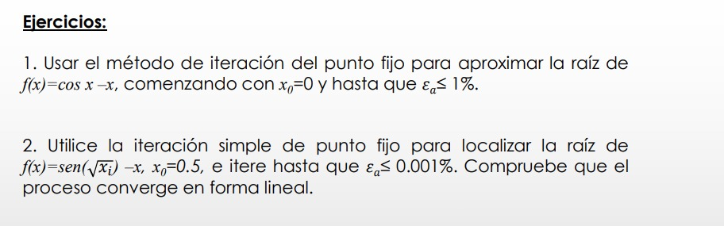

clear all

syms c;

f=cos(c);

xr(1)=double(subs(f,c,0));

iter(1) = 1;

imax = 30;

es=1;

ea(1)=100;

i = 1;

while abs(ea(i)) >= es && i < imax

xr(i+1) = double(subs(f,c,xr(i)));

iter(i+1) = i + 1;

if xr ~= 0

ea(i+1) = abs((xr(i+1)-xr(i))/xr(i+1))\*100;

end

i = i + 1;

end

table(iter',xr',ea','VariableNames',{'I','Xr','Ea'})

clear all

syms c;

f=sin(sqrt(c));

xr(1)=double(subs(f,c,0.5));

iter(1) = 1;

imax = 30;

es=0.001;

ea(1)=100;

i = 1;

while abs(ea(i)) >= es && i < imax

xr(i+1) = double(subs(f,c,xr(i)));

iter(i+1) = i + 1;

if xr ~= 0

ea(i+1) = abs((xr(i+1)-xr(i))/xr(i+1))\*100;

end

i = i + 1;

end

table(iter',xr',ea','VariableNames',{'I','Xr','Ea'})

